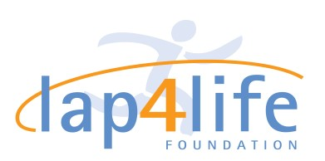
Pledge Page

If you raise $100.00 or more your race entry will be waived. All pledges must be in by June 5, 2018 with race application. Checks only please. Please make checks out to Lap 4 Life Foundation, thank you!

Runner / Walker Name: _________________________________________________________________
Contact Info (Email/Phone/Address)________________________________________________________

Sponsor Name Total $ email phone number
ex. John Smith $20.00 jsmith@yahoo.none (845)-333-2323
1.
2.
3.
4.
5.
6.
7.
8.
9.
10.
11.
12.
13.
14.
Prize for person raising the most money through Pledges !!

